|  |  |  |  |  |
| --- | --- | --- | --- | --- |
| **PENGAJUAN DANA** | | | | |
| **No** | **Nama Barang** | **Banyak** | **Harga** | **Total** |
| 1 | IMAX B6AC V2 80W CHARGER DISCHARGE BATERAI AC ADAPTER LIPO RC ORIGINAL | 1 | Rp274.000 | Rp274.000 |
| 2 | JGA25-12CPR 1:34 Motor DC Gearbox Magnetic Encoder | 4 | Rp180.000 | Rp720.000 |
| 3 | Lipo Battery 3s 11.1v 2800mah 50-100c Onbo Power | 2 | Rp422.000 | Rp844.000 |
| 4 | MPU6050 MPU-6050 3 AXIS ANALOG GYROSCOPE ACCELEROMETER MODULE | 3 | Rp19.900 | Rp59.700 |
| 5 | KOTAK SAMPAH C-4 10LT LS / TEMPAT SAMPAH 10lt LION STAR | 5 | Rp47.500 | Rp237.500 |
| 6 | Motor Driver BTS7960 43A BTS7960B | 4 | Rp57.000 | Rp228.000 |
| 7 | Akrilik 5mm | 1 | Rp300.000 | Rp300.000 |
| 8 | Roda Omni Metal 58MM Omniwheel Omnidirectional Wheel Alumunium | 4 | Rp200.000 | Rp800.000 |
| 9 | Braket Dudukan Motor Dinamo 370 380 385 390 395 Reducer | 4 | Rp22.000 | Rp88.000 |
| **Total Biaya** | | | | **Rp3.551.200** |

**LAMPIRAN**

1. IMAX B6AC V2 80W CHARGER DISCHARGE BATERAI AC ADAPTER LIPO RC ORIGINAL

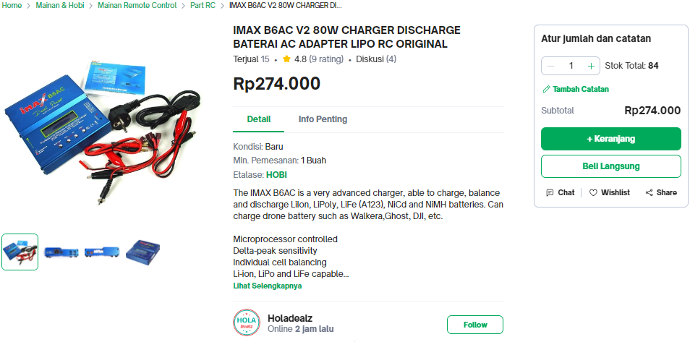

1. JGA25-12CPR 1:34 Motor DC Gearbox Magnetic Encoder

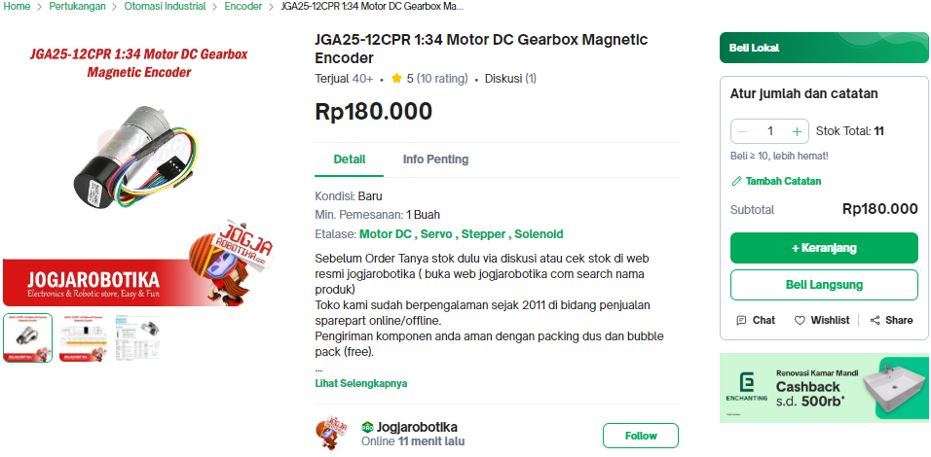

1. Lipo Battery 3s 11.1v 2800mah 50-100c Onbo Power

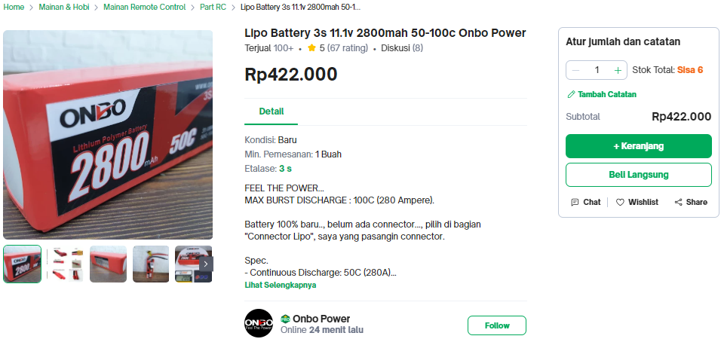

1. MPU6050 MPU-6050 3 AXIS ANALOG GYROSCOPE ACCELEROMETER MODULE

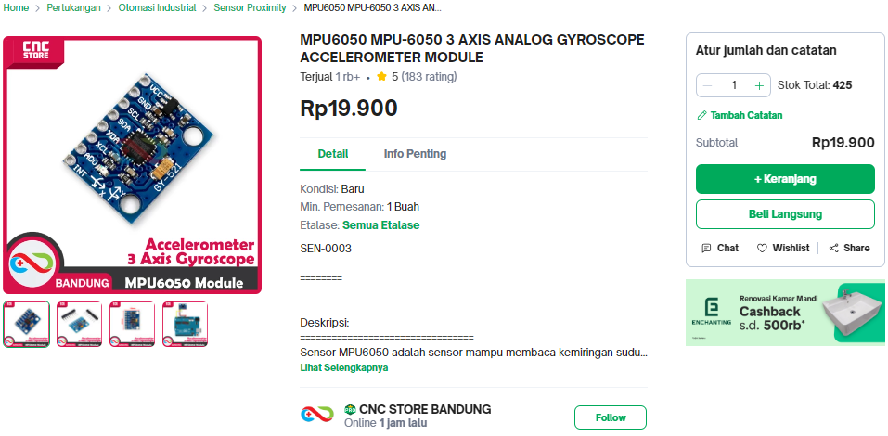

1. KOTAK SAMPAH C-4 10LT LS / TEMPAT SAMPAH 10lt LION STAR

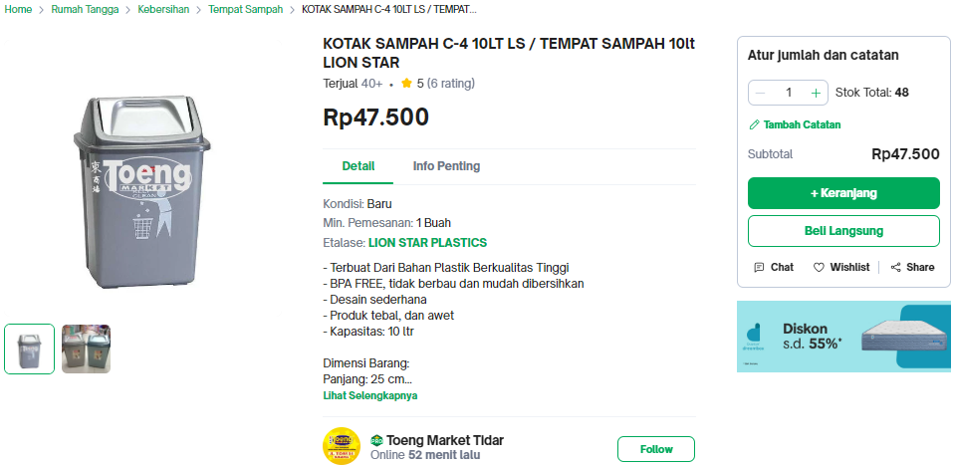

1. Motor Driver BTS7960 43A BTS7960B

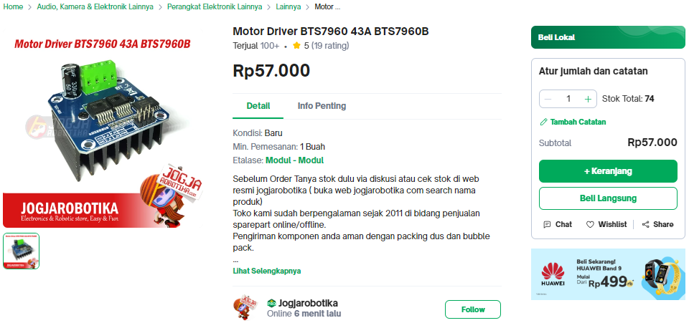

1. Akrilik 5mm (OFFLINE)
2. Roda Omni Metal 58MM Omniwheel Omnidirectional Wheel Alumunium

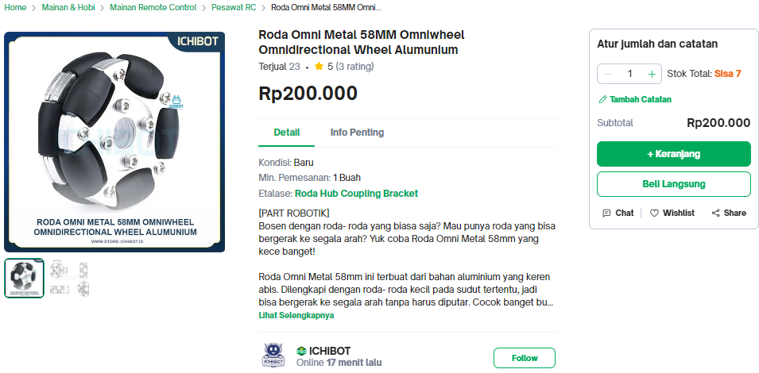

1. Braket Dudukan Motor Dinamo 370 380 385 390 395 Reducer

